ECA18 – OPTOELECTRONICS AND OPTICAL COMMUNICATION
CO5 – Case Study Based Assignment
Title: DWDM Metro Link Commissioning: From Field Measurements to a Standards-Based Upgrade Decision
Abstract:
Dense Wavelength Division Multiplexing (DWDM) is an important technology for increasing the capacity of optical communication networks without installing additional optical fibres. This case study investigates the commissioning and upgrading of a 60 km ITU-T G.652.D optical fibre link carrying eight 10 Gb/s NRZ channels on a 100 GHz wavelength grid. Although Channel 3 provides an acceptable eye diagram, Channel 5 shows a partially closed eye, low extinction ratio, increased jitter and a high bit error rate (BER). Optical power measurements also indicate that the required receiver margin may not be available.
The proposed study combines optical power budgeting, chromatic dispersion analysis, optical signal-to-noise ratio (OSNR) evaluation, optical time-domain reflectometry (OTDR), eye-diagram analysis and quantum detection limits. The OTDR events are examined to identify a mechanical splice, a high-loss patch-panel connector and two closely spaced connectors. Corrective actions are proposed to reduce excess loss and improve link reliability. The BER and jitter calculations are used to evaluate the quality of the two observed channels and determine whether the impairment is shared by the fibre or specific to Channel 5.
Finally, three upgrade options are compared in terms of transmission capacity, spectral occupancy, OSNR requirement, module power consumption and energy per bit. The report recommends repairing and verifying the existing optical path before selecting a standards-based coherent DWDM upgrade. Deployment is conditional on demonstrating adequate receiver margin, acceptable BER, sufficient OSNR and correct wavelength-grid operation through end-to-end testing.
Introduction:
Optical fibre communication provides high bandwidth, low attenuation and reliable long-distance data transmission. In metro networks, multiple optical signals are transmitted simultaneously through the same fibre using DWDM. Each signal occupies a different optical wavelength, allowing the network capacity to increase without laying new fibre.
The case study considers a 60 km G.652.D optical fibre link connecting two data centres. The existing system carries eight 10 Gb/s NRZ channels, giving a total capacity of:
$$C=8×10=80\text{ Gb/s}$$
The link uses a 100 GHz ITU-T G.694.1 frequency grid and a transmit booster EDFA. During commissioning, Channel 3 shows an open eye diagram, while Channel 5 shows eye closure, higher jitter and a reduced extinction ratio. OTDR measurements reveal several events that may contribute to optical loss and reflection.
The operator intends to increase the capacity to 1.6 Tb/s using the existing fibre pair. Therefore, the engineering team must identify the causes of poor performance, correct the optical path, verify the link budget and choose an upgrade technology that satisfies capacity, spectral and energy requirements.
Objectives:
- Analyse the measured optical link loss and receiver power margin.
- Calculate dispersion penalty, PMD and OSNR.
- Interpret OTDR events and prioritize field repairs.
- Evaluate eye diagrams, Q-factor, BER and jitter.
- Compare direct detection with coherent detection limits.
- Compare DWDM upgrade options using spectrum, OSNR and energy per bit.
- Develop an integrated repair, verification and deployment plan.

Scope of the study:
The study covers the existing 60 km fibre path, the eight legacy optical channels, the identified splice and connector faults, and the proposed 1.6 Tb/s upgrade. It considers the specified G.652.D fibre and G.694.1 channel grid without replacing the installed fibre.
Eye-diagram interpretation:
An open eye indicates adequate separation between logic levels and sufficient timing margin. A partially closed eye may result from noise, intersymbol interference, jitter, low extinction ratio or transmitter defects.Channel 3 has (Q=7.6) and an extinction ratio of 9.0 dB. Channel 5 has (Q=4.7) and an extinction ratio of 4.5 dB. Since the channels share the same fibre, the substantially worse result for Channel 5 suggests a channel-specific impairment in addition to any common link-budget issue.
OTDR measurement limitations
OTDR performance depends on pulse width, dynamic range, event dead zone and attenuation dead zone.
- Dynamic range: Determines whether the backscattered signal can be detected at the far end.
- Event dead zone (EDZ): Determines how close two reflective events can be while remaining distinguishable.
- Attenuation dead zone (ADZ): Determines how close events can be while allowing their individual losses to be measured accurately.
- Pulse width: A longer pulse increases dynamic range but reduces spatial resolution.
Applicable standards and practical constraints
- ITU-T G.652.D: Specifies characteristics of the installed single-mode optical fibre.
- ITU-T G.694.1: Defines the DWDM frequency grid, including fixed-grid and flexible-grid arrangements.
Fusion splicing is preferred for permanent fibre joints because it generally offers low loss and low reflection. Mechanical splices are useful for temporary or field repairs but may introduce greater loss and reflection.
LC connectors are compact and suitable for high-density data-centre panels. SC connectors are larger and widely used in conventional fibre infrastructure. MPO connectors support multiple fibres in one connector, while CS connectors provide compact, high-density connections. UPC and APC refer to end-face polishing; APC is generally preferable where low back reflection is important, provided that the equipment and mating interfaces are compatible.
Performance requirement statement:
The repaired 60 km link must support reliable transmission with at least 3 dB receiver margin, BER no worse than (10^12), Q-factor of at least 7.03, adequate OSNR, controlled dispersion and no unacceptable connector or splice loss. The upgraded system must provide 1.6 Tb/s on the existing fibre pair, use an ITU-T G.694.1-compatible channel plan and minimize energy per transmitted bit.
Stage 1 – Link Budget, Dispersion and OSNR Analysis
Fibre attenuation
The fibre attenuation is calculated using:
$$L_{f}=αL$$
Given (alpha=0.21{ dB/km}) and (L=60{ km})
$$L_{f}=0.21×60=\boxed{12.60\text{ dB}}$$

Design link loss:
Component | Calculation | Loss
Fibre | 60*0.21 | 12.60db
Four connectors | 4*0.5 | 2.00db
Thirteen splices | 13*0.05 | 0.65db
Demultiplexer | given | 6.00db
Total Design Loss |  | 21.25db
Therefore,
$$L_{\text{design}}=12.60+2.00+0.65+6.00$$
$$\boxed{L_{\text{design}}=21.25\text{ dB}}$$
As-built link loss:
The case study provides an as-built total loss of 22.52 dB in its verification table. This is 1.27 dB greater than the design allowance.
$$L_{\text{excess}}=22.52-21.25$$
$$\boxed{L_{\text{excess}}=1.27\text{ dB}}$$

The measured connector and splice information also identifies a 0.62 dB mechanical splice and a 1.20 dB patch-panel event. However, the event loss and power-meter connector totals cannot be added indiscriminately because they may describe overlapping physical losses.
Therefore, 22.52 dB is used as the supplied commissioning baseline, while the exact component-by-component loss must be reconciled with calibrated insertion-loss measurements.
Received optical power:
The received power before additional signal-quality penalties is:
$$P_{r}=P_{t}-L_{\text{total}}$$
Given the per-channel launch power $P_{t}=+1\text{ dBm}$
$$P_{r}=1-22.52$$
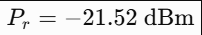
The minimum power needed to achieve the specified 3 dB margin is:
$$P_{\text{required}}=-24+3=-21\text{ dBm}$$
The raw received power is therefore 0.52 dB below the required level.
Chromatic dispersion penalty:
The given relation is:
$$δ=5\log_{10}\left[1+2π{\left(BDLσ_{λ}\right)}^{2}\right]$$
For this Calculation, B=10^10HZ, D=17 ps\(nm km), L=60km, and $σ_{λ}=0.03\text{ nm}$
After converting the units consistently,
$$BDLσ_{λ}={10}^{10}\left(17×{10}^{-12}\right)\left(60\right)\left(0.03\right)=0.306$$
Therefore,
$$δ=5\log_{10}\left[1+2π{\left(0.306\right)}^{2}\right]$$
$$\boxed{δ≈1.10\text{ dB}}$$
This is an estimated dispersion penalty under the supplied model. The actual penalty should be validated against the measured transmitter chirp, receiver characteristics and eye diagram.
Extinction-ratio penalty:
The extinction ratio (ER) represents the difference between the optical power levels corresponding to logical ones and zeros.
The following approximate penalty model can be used to compare the channels:
$$δ_{ER}=10\log_{10}\left(\frac{r+1}{r-1}\right)$$
Where r=10^ER/10
For channel 3:
$$r_{3}={10}^{9/10}=7.943$$
$$δ_{ER,3}≈0.99\text{ dB}$$
For channel 5:
$$r_{5}={10}^{4.5/10}=2.818$$
$$δ_{ER,5}≈2.65\text{ dB}$$
These are illustrative penalties from the selected model, not measured penalties supplied by the case. The receiver-sensitivity specification is valid only for ER of at least 8.2 dB, so the sensitivity cannot be assumed valid for Channel 5.
OSNR analysis:
The supplied approximation is:
$$OSNR=58+P_{in}-NF$$
using the given EDFA input power of −6 dBm per channel and noise figure of 5 dB:
$$OSNR=58-6-5$$
$$\boxed{OSNR=47\text{ dB}}$$
This formula produces a nominal estimate of 47 dB. It is not a complete receiver OSNR calculation: a real result requires the amplifier output power, ASE noise, reference bandwidth, channel loading and downstream optical losses.
Under the supplied approximation, the OSNR exceeds the legacy requirement of 20 dB. Thus, the immediate commissioning symptoms point more strongly toward insufficient power margin and Channel 5 signal-quality degradation than toward a demonstrated OSNR failure.
PMD tolerance:
The RMS differential group delay is estimated by:
$$Δτ_{PMD}=D_{PMD}\sqrt{L}$$
$$Δτ_{PMD}=0.1\sqrt{60}$$
$$\boxed{Δτ_{PMD}≈0.775\text{ ps}}$$
At 10 Gb/s, the bit period is:
$$T_{b}=\frac{1}{{10}^{10}}=100\text{ ps}$$
The 10% tolerance is:
$$0.1T_{b}=10\text{ ps}$$
Since 0.775 ps<10 ps, the estimated PMD is within the specified tolerance.
Design Decision 1 – Link-budget configuration:
I recommend repairing the excessive-loss connector and mechanical splice first, then repeating insertion-loss and received-power measurements. After repairing the optical path, the link must be checked for at least 3 dB margin after the applicable penalties. Any launch-power increase should be made only after checking transmitter limits, amplifier saturation, channel loading and receiver overload.
The supplied baseline loss of 22.52 dB must be reduced by at least 1.27 dB to reach the design loss of 21.25 dB. Merely restoring that design loss may still not provide the required margin after dispersion and signal-quality penalties.
Stage 3 – OTDR Fault Localization, Splice and Connector Selection
OTDR pulse-width selection
The OTDR pulse's approximate spatial length in fibre is:

$$d=\frac{ct}{2n_{g}}$$
where (c=2.998*10^8 m/s) and (ng=1.4682).
Pulse Width | Spatial Pulse Length | Dynamic Range | EDZ | ADZ
10ns | 1.02m | 20db | 1m | 4m
100ns | 10.21m | 27db | 5m | 15m
1microsecs | 102.10m | 33db | 40m | 100m

The estimated minimum dynamic range requirement is:
$$DR_{required}≈L_{trace}+6\text{ dB}$$

If the measured trace loss is approximately 22.52 dB, then:
$$DR_{required}≈28.52\text{ dB}$$
The 10 ns and 100 ns settings do not satisfy this conservative requirement. The 1 μs setting does, but its dead zones are too large for accurate measurement of the two connectors separated by only 9 m.
Therefore, two complementary OTDR tests are recommended:
- Use a long pulse, such as 1 μs, to locate far-end events and obtain adequate dynamic range.
- Use a short pulse, preferably 10 ns, for detailed analysis of the nearby connectors, with launch and receive fibres to separate the end connectors from the instrument dead zone.
The short-pulse trace should be treated as a local high-resolution test rather than proof that the full 60 km trace has adequate dynamic range.
Interpretation of OTDR events:
Event 1:A 0.05 dB non-reflective event is consistent with a low-loss splice. It falls within the stated 0.05 dB allowance and is not the first repair priority.
Event 2:A 0.62 dB loss is significantly greater than the 0.05 dB splice allowance. Its reflectance of −34 dB indicates a reflective discontinuity consistent with a mechanical splice or an imperfect joint.
The preferred permanent repair is to replace the mechanical splice with a properly prepared fusion splice, targeting a loss of approximately 0.05 dB or better.
Events 3 and 4:Event 3 has the largest explicitly stated OTDR loss, at 1.20 dB. Its reflectance of −22 dB is also relatively high and is consistent with a poor optical connection.
The connector should be inspected for contamination, scratches, damaged end faces, incorrect mating or misalignment. If cleaning and remating do not restore acceptable performance, replace it.
Event 4 must be checked separately because its loss is unresolved. A 9 m separation means a long-pulse trace may merge the two events, creating a misleading combined-loss reading.
Round-trip delay calculations:
The approximate round-trip time is:
$$t_{RT}=\frac{2n_{g}L}{c}$$
The round-trip time per kilometre is =9.79microsec/km
The 9 m separation between events 3 and 4 corresponds to approximately 88 ns of round-trip delay.
Repair priority
- Highest priority – Event 3: Investigate and correct the 1.20 dB patch-panel loss and relatively high reflectance.
- Second priority – Event 2: Replace the 0.62 dB mechanical splice with a low-loss fusion splice.
- Third priority – Event 4: Resolve the unmeasured loss using a short-pulse OTDR test and verify the patch cord.
- Retain – Event 1: Keep the 0.05 dB splice if repeat measurements confirm acceptable performance.
Although Event 3 is the highest immediate priority because of its measured loss, Events 3 and 4 should be assessed together during the patch-panel repair because their separation complicates measurement.
Repair verification
After repair:
- Repeat OTDR measurements at 1550 nm with both short- and long-pulse settings.
- Confirm that no unacceptable reflective or high-loss event remains.
- Measure end-to-end insertion loss using a calibrated optical source and power meter.
- Compare measured loss against the 21.25 dB design allowance, including the demultiplexer.
- Measure channel power and OSNR using the OSA.
- Repeat eye-diagram and BER testing at the receiver.

Design Decision 2 – OTDR configuration

I recommend a dual-pulse OTDR test arrangement because the long pulse provides the required dynamic range, while the short pulse resolves the two connectors only 9 m apart. Event 3 should receive the highest repair priority, followed by Event 2. Event 4 must be measured separately before accepting the patch-panel repair.

Energy comparison

Module energy per bit at 1.6 Tb/s

Option R has the lowest module power and energy per bit. These figures exclude EDFAs, cooling, switching, FEC processing, control electronics and other system-level power consumption. They should therefore be interpreted as module-level comparisons, not total data-centre energy figures.
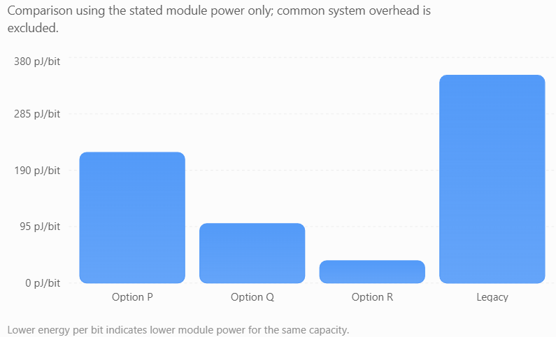


Role of silicon photonics:
Silicon photonics integrates optical components such as modulators, waveguides and multiplexing structures onto compact photonic circuits. It can reduce component size and support high-density optical interfaces.
Its advantages include:
- Reduced module power and physical size in suitable implementations.
- High integration density.
- Potential manufacturing scalability.
- Improved suitability for compact, high-capacity data-centre links.
However, the actual power benefit depends on the complete transceiver design, including laser sources, DSP, FEC and thermal management. Option R must still demonstrate its required OSNR and acceptable BER on the repaired link.
Selected upgrade option
Option Q is selected as the preferred initial engineering design, subject to measured performance validation.
The reasons are:
- It achieves the target capacity of 1.6 Tb/s.
- Its allocated spectrum is approximately 300 GHz, compared with 800 GHz for Option P.
- Its module power is 160 W, significantly below Option P and the legacy solution.
- Its required OSNR of 19.5 dB is less demanding than Option R's 26 dB.
- Its flexible grid allows more efficient spectrum allocation.
Option R is the preferred option on module energy alone. It should be reconsidered if the measured OSNR, transceiver implementation and end-to-end BER are shown to meet its more demanding operating requirements.
Expected loss after repair
The supplied commissioning loss is 22.52 dB. The required reduction to meet the design loss is:
Delta L=22.52-21.25
Delta L=1.27{ dB}
The stated excess-loss contributions indicate that repairing Event 3 and replacing Event 2 should substantially improve the link. However, the precise repaired loss cannot be confirmed until the overlapping event and connector measurements are reconciled.
For the proposed design, the acceptance target is a measured total loss of no more than 21.25 dB, including the demultiplexer. This is a target, not a measured post-repair result.
Integrated repair and upgrade sequence:

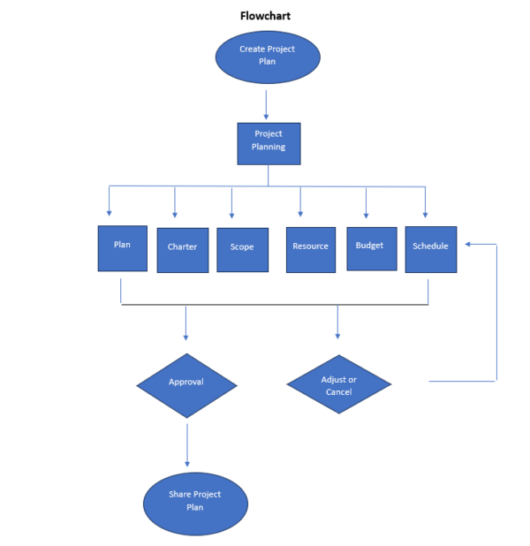

Conclusion:
This case study evaluated a 60 km DWDM metro link carrying eight 10 Gb/s NRZ channels and developed a repair and upgrade strategy for a target capacity of 1.6 Tb/s. The calculations identified a supplied as-built loss of 22.52 dB against a design allowance of 21.25 dB. OTDR analysis identified a high-loss mechanical splice, a poor patch-panel connector and two closely spaced connector events requiring different pulse-width settings for reliable diagnosis.
The eye-diagram and BER analysis showed that Channel 3 meets the Q-derived BER target, while Channel 5 fails because of its low extinction ratio, higher jitter and reduced Q-factor. The PMD estimate is within the specified tolerance, and the simplified OSNR calculation suggests that power margin and channel-specific signal quality deserve priority during commissioning.
Among the upgrade alternatives, Option Q provides 1.6 Tb/s using approximately 300 GHz of allocated spectrum and a calculated module energy of 100 pJ/bit. It offers a balance between spectral efficiency, power consumption and OSNR requirements. However, the actual receiver OSNR and post-repair margin must be measured before deployment.
Therefore, the final engineering decision is to repair, recommission and verify the existing fibre before activating the upgraded system. This approach improves reliability, avoids unnecessary fibre replacement and supports a standards-based capacity increase, subject to successful acceptance testing.
Refrences:
1. Liu, H., Zhao, T., & Zhang, M. (2025). OTDR development based on single-mode fiber fault detection. Sensors, 25(14), Article 4284.
2. Kulandaivel, S., & Jeyachitra, R. K. (2025). Novel wavelet decomposition-parallel neural network for accurate OSNR monitoring in optical systems using contrast enhanced optical spectrum. Optics Communications, 596, Article 132527.
3. Zhao, T., Wen, F., Wu, B., Xu, B., & Qiu, K. (2024). Time-frequency dual-dimension deep neural network (TF-DD-DNN)-based OSNR and XT monitoring in mode-division multiplexing systems. Optics Communications, 565, Article 130649.
4. Zhang, D., Zhang, H., Cao, Y., & Xue, Y. L. (2024). Combined modulation format identification and optical signal-to-noise ratio monitoring with high accuracy and generalizability based on a proposed fused module few-shot learning algorithm in dynamic coherent optical transmissions. Optics Express, 32(8), 14719–14734.
5. Liu, H., Zhao, T., & Zhang, M. (2025). Synchronously realizing high spatial resolution and precise location for fiber fault attenuation event detection. Optics Letters, 50(11), 3732–3735.

